Here are the tips for the supports. Sometimes, we must deal with the complicated models. Like the picture below. Let us setup and appropriate support for this model (**nose_rail.stl**).

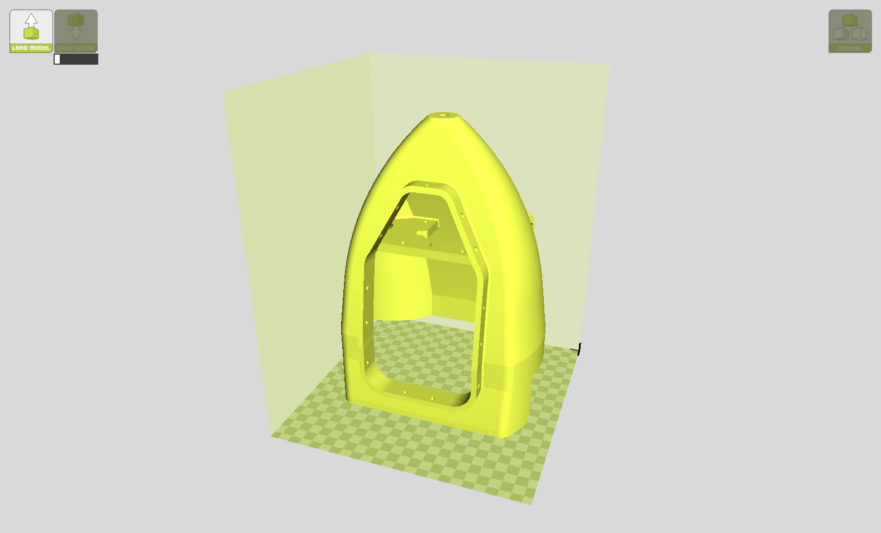

1. Select the Support Type to “Touching Buildplate”, then click the ”…” to modify the option.

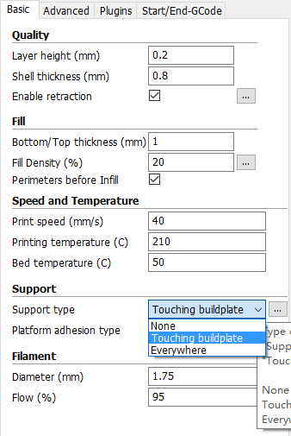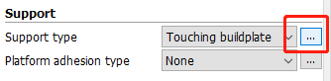

1. Use the following settings. Structure Type to “Lines”, Angle for Support (deg) “60”.

Reduce the Fill Amount (%) to “10” (**must be greater than 7**).

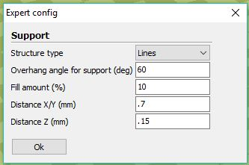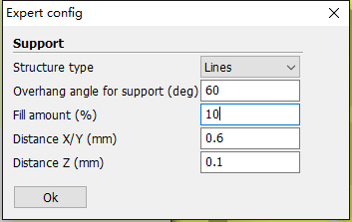

1. Use “Layers” View to check the details of support.

We can see that the distance between lines supports (blue parts) are about 6mm (the size of rectangular on the green back ground is 1cm, 10mm). The default printing speed is 40mm/sec (check your own printing speed to ensure), **which means the time cost between two lines is 0.15 sec, it is acceptable, but 0.1 sec would be perfect.**

You can either increase the printing speed to 50~60 mm/sec (to scarify the quality), or reduce the “Distance X/Y (mm)” in **Step#2** from **0.6 to 0.5 or less** (time cost enhanced).

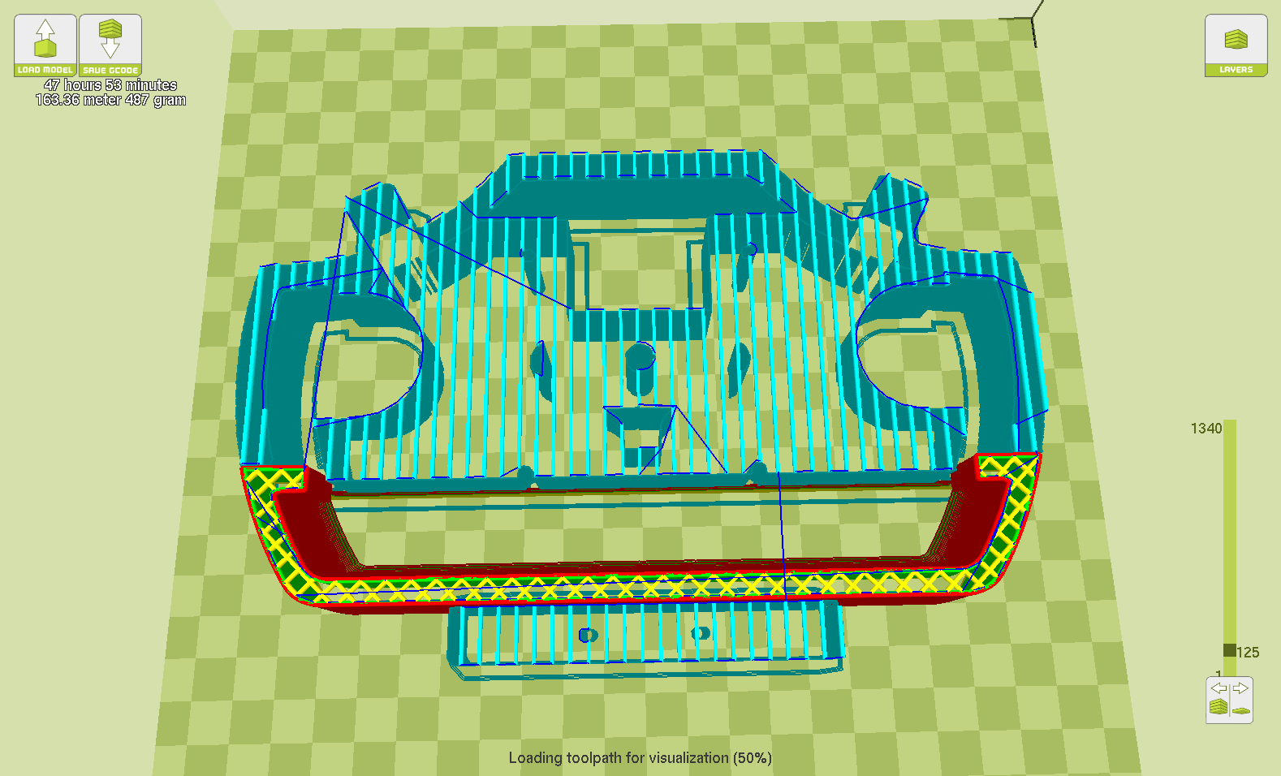

That’s it. Simple and straightforward.